VEX V5 Override: Session 2 - Virtual Driving Station

Activity: Drive Flex to score points in Virtual Driving Skills Practice!

- Open V5 Override Virtual Driving Skills Practice.
  - You need your Team Number and Virtual Skills Key from your Coach in order to access the game.

- Make a plan for how you will score points with Flex.
  - Robot Skills has some slightly different rules and scoring from Head to Head Matches. Review those differences and similarities in Section 3 of the game manual.
  - Use tools like images of the Field to help you plan and document your path for the robot to score points.

- Drive Flex to score as many points as you can in 60 seconds!
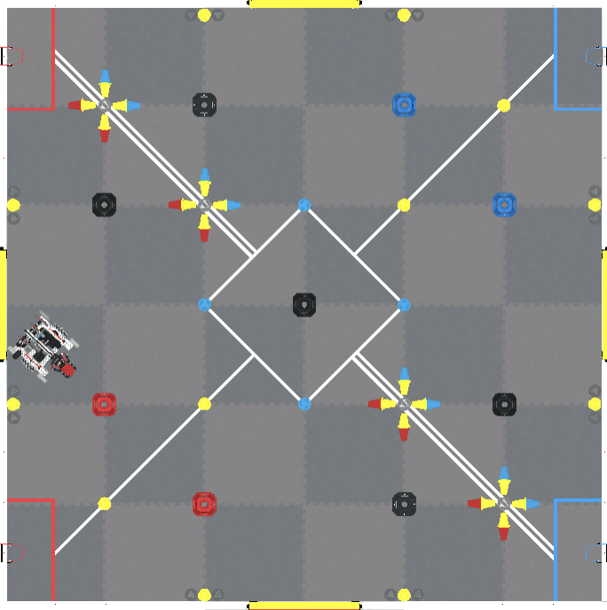
Example Documentation:

Driving Steps:

Feeling Stuck?
- Learn more about the controls for Flex and how to change the settings for the Drive Mode robot configuration, and controller button mapping in this article.

Discussion Questions  - How does your previous experience with Virtual Driving Skills Practice impact your plans for this activity?  - What do you think is the most efficient path for Flex to score points? Why?  - How are you deciding what robot and Controller options to use when driving Flex? | Activity Checklist  - Each team member read the Robot Skills section of the manual.  - Each team member documented a plan for their driving.  - Each team member drove in at least 2 Virtual Driving Skills Practice matches.

